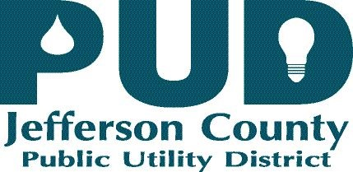
Board of Commissioners:

Jeff Randall, District 1
Kenneth Collins, District 2
Dan Toepper, District 3

Kevin Streett, General Manager

June 9, 2020

Public Notice of a PUD BOC Special Meeting June 16, 2020

NOTE: Per Governor’s Proclamation 20-28, and in response to the COVID-19 pandemic, Jefferson County PUD will no longer be providing an in-person room for meetings of the BOC. All meetings will only be accessible remotely via WEBEX until we have further information on anymore extensions, by Governor Order

The Jefferson County PUD Board of Commissioners will hold a Special meeting on June 16, 2020 4:30 pm, and will then hold an Executive Session to consider the minimum price at which real estate will be offered for sale or lease when public knowledge regarding such consideration would cause a likelihood of decreased price pursuant to RCW 42.30.110 (1) (c) . This meeting will be held per WEBEX.

For any questions regarding this meeting please contact the undersigned at 360-385-8360.

Sincerely,

Kevin Streett
General Manager

PUBLIC UTILITY DISTRICT #1
Of Jefferson County

Meeting per WEBEX

June 16, 2020

SPECIAL MEETING/EXECUTIVE SESSION

AGENDA

Call to Order

Agenda Approval

Dismiss to Executive Session: To discuss and consider the selection of a site or the acquisition of real estate pursuant to RCW. 42.30.110 (1) (c)

Discussion

Adjournment

